**Name: Ajinkya Anand Thakur**

**Roll no: 2401199**

**Student Management API**

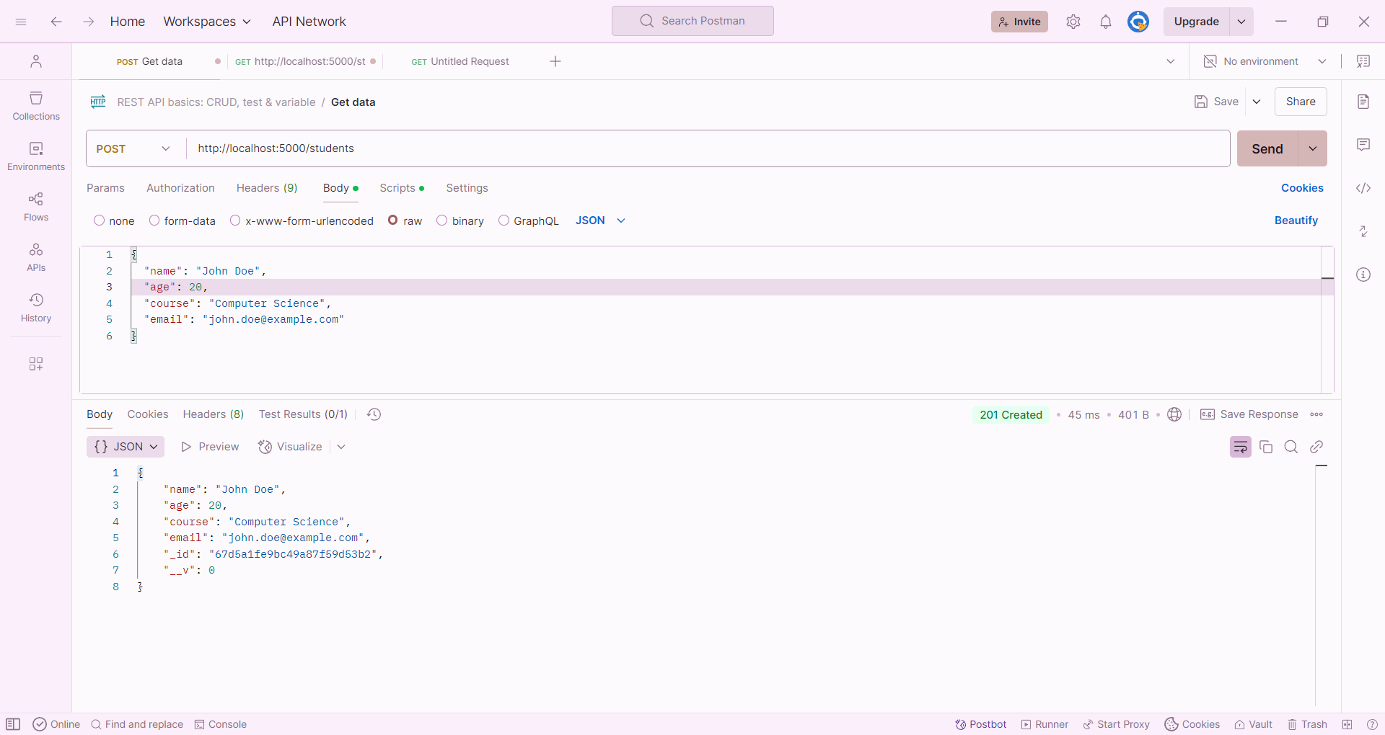

**Book Library API**

